Dynamic System Analysis Using Traditional, Laplace and Linear Algebra Method

SP3 – Traditional, Laplace, and Linear Algebra Methods

By: Abbas Hussain, Mihiret Tolessa, Ali Aladhab.

OCT 19, 2024

ME 351 Analytical Methods in Engineering

Fall Semester 2024

Prof. Zelalem Eshete

**Introduction**

In this project, we analyzed the behavior of second-order dynamic systems using both traditional methods and Laplace transforms. The focus was on systems with varying damping conditions, including undamped (ζ=0), underdamped (ζ=0.3), and overdamped (ζ=1.2) scenarios. We solved both homogeneous and non-homogeneous differential equations to understand how these different damping ratios affected the system response. The project explored cases with no external forces, constant forces, and sinusoidal inputs. MATLAB was used to conduct numerical simulations, which helped verify the analytical solutions and provide deeper insights into the system's transient and steady-state behavior.

**Discussion**

**1.Calculations**

**Case 1:**

In this case we had to use the differential equation of mx’’+cx '+kx=f and solve it in different forms such as the traditional method, the Laplace method and the linear algebra method. We were to only consider undamped underdamped with a constant ζ = 0.3 and overdamped at a constant ζ = 1.2. The system parameters in this case were f(t)=0, x (0) =x_0, and v(0)=v_0. m=1 and k=4 for the parameters as well.

**(a) Undamped ζ = 0**

For undamped we have 3 different methods, and we will have 3 methods for all other cases. In the undamped case of traditional, we get a value of s=+-2i, and we get a solution of x(t)=Acos(2t)+Bsin(2t), and we use the initial conditions and end up with cos(2t). For the undamped version of the Laplace we solve for x(s) and then input the values of m=1 and k=4 into the equation. What you are left with is s/s^2+4, you then use partial fraction decomposition and end up with the same answer of cos(2t). For the linear algebra approach of the undamped you use determinants and values for lambda imaginary numbers +-2i and input to v1 and v2. You still end up with the same Cos(2t) for x(t).

**(b) Underdamped** ζ **= 0.3**

In the underdamped case, for traditional we have a value for zeta of c=1.2, you take this and input it into the characteristic equation which this time around is s^2+1.2s+4=0, and you then take s to be the complex roots of -0.6+-1.905i, when inputting this into the solution you end up with x(t)=e^-0.6t(cos1.905t). For the Laplace method, you use your previous value of x(t)=cos(2t) and input it into the new x(t) which is e^-0.15t(Acos (1.994t)+Bsin(1.994t)). For the linear algebra approach we solved for c again which gives us c=1.2. We then take the matrix of A and solve for the determinate. We get our new value of lambda which is -0.6a+-1.905i and use the initial conditions to solve for x(t).

**(c) Overdamped** ζ **= 1.2**

For the overdamped traditional method, we have a value of c=4.8, we sub that into the equation, s^2+4.8s+4=0 to get the real root of s=-2.4+-1.6. We then get a solution of x(t)=Ae^-0.8t+Be^-4t. For the Laplace method we take the x(s) value where c=1.2 and end up with the same solution as the one for the traditional method. For the overdamped linear algebra approach, we use the value of c=4.8 and like the other two processes for the linear algebra method we solve the determinant. This time we must solve a quadratic to get the values for the lambdas. When solved we end up with a fraction for lambda of -4.8+-2.828/2, and when solving we get lambda1=-3.814 and lambda2=-0.986. In the end we get the same x(t) equation as the previous two.

**Case 2:**

We must apply traditional, and Laplace transform techniques to get our outcome. In this case, we were given a forced sinusoidal differential equation, m𝑥''+𝑐𝑥'+𝑘𝑥 =F0, to track and examine its behavior. We must test these equations using the designated variable damping state during the simulation for scenario 2. The variables k=4, m=1, wn=2, and F0=6 were chosen, and the initial conditions were x (0) = 0 and v(0) = 0.

**(a) Undamped** ζ **= 0**

The undamped case as given $ξ=0$: when damping is absent the characteristic equation turns into: $mr^{2}+k=0$ and $r=±i\sqrt{\frac{m}{k}}$ This solution is oscillatory. $x(t)=Acos(w_{0}t)+Bsin(w_{0}t)$. where $w_{0}=mk$ in the natural frequency. Our solution was divided into two sections: the homogeneous solution and the specific solution because this instance is a non-homogeneous version. After following more equation solving, we obtained an overall solution structure of $x(t)=-A(w_{n})sinw_{n}t+B(w_{n})cosw_{n}t$. Lastly after plugging in all the parameters, we get the following; $x(t)=-1.2cos2t+1.2sin(t)$.

**(b) Underdamped** ζ **= 0.3**

A reaction with a damping ratio of less than one that oscillates inside a decaying envelope is said to be underdamped. The system will oscillate more and take longer to reach steady state if it is underdamped. A system with a damping ratio between one and zero is said to be underdamped. Our solution was divided into two sections, the homogeneous solution and the specific solution because this instance is a non-homogeneous version. The underdamped in this case was given as, $ξ$ =0.3. Since the discriminant in this case is negative, we have complex roots. The characteristic equation turns into $x"+2ξw_{n}x'+{w_{n}}^{2}=0.$ After some calculations the equation turn into,

$x(t)=e^{-ξwnt}Acos(w_{n}\sqrt{ξ-1^{2}}t)+Bsin(w_{n}\sqrt{1-ξ^{2}}t)+\frac{F_{0}}{k}$ After following more equation solving, we obtained an overall solution solution of $x(t)=e^{-0.998t}(-1.2cos(3.01t)-30.1sin(3.01t)+1.2$. The steps on how this is obtained will be posted in the appendix section.

**(c) Overdamped** ζ **= 1.2**

When a mechanical system is overdamped, it implies the damping force is so great that the system returns to equilibrium without fluctuating. Systems having a damping ratio larger than one experience this effect, which results in slower motion and extended settle periods than underdamped. For the given overdamped system zeta = 1.2. Much greater value than the underdamped system. The discriminant is positive, leading to real roots. The solution takes the form $yh(t)=e^{-c/2mt}$. Since this case is an overdamped case, the inverse Laplace transform will involve exponentials with real coefficients. As I was observing the sinusoidal curve (top plot, cyan) A step force, $f(t)=F_{0}$, causes the system to jump suddenly. This is followed by oscillations that eventually stop when the system settles compared to the other two cases. Upon applying the step force, the output of the system abruptly jumps. This is because there is an instantaneous reaction when the input changes from one value to another. The mechanism frequently oscillates after the initial jump, the system is attempting to reach a new equilibrium. Our solution was divided into two sections, the homogeneous solution and the particular solution because this instance is a non-homogeneous version. The overdamped in this case was given as, $ξ$ =1.2. Since the discriminant in this case is positive, we have real roots. Our equation is turns into $mx''+cx'+kx=F_{0}$. After solving, the characteristic equation turns into $x(t)=F_{0}/k+\frac{F_{0}r_{2}}{k(r_{1}-r_{2})}e^{r_{1}t}+\frac{F_{0}(-r_{1})}{k(r_{1}-r_{2})}e^{r_{2}t}$. After plugging in the values we obtained, $x(t)=1.2-1.68e^{-1.69t}+0.4854e^{-5.888}.$ The steps on how this is obtained will be posted in the appendix section.

**Case 3:**

In this case we were given a forced sinusoidal differential equation $mx''+cx'+kx=F_{0}cos(wt$). We had to test this equation with the given varying damping conditions in order to observe and analyze its behavior throughout the experimentation. We were supposed to use the traditional method and laplace transform method to obtain our results for this case. For this case the system parameters that we chose were $F_{0}=6$, m = 1, k = 4, ⍵ = 1 and the given initial conditions were $x(0)=0$ and $v(0) = 0$.

**(a) Undamped** ζ **= 0**

In this damping condition, we were instructed that ζ=0, which meant that the damping constant c, was also 0. Given that there is no damping in this part of the case, we were supposed to obtain completely unrestricted sinusoidal results from this equation. As this case is a non-homogeneous variant, our solution was split into two parts, homogeneous solution and particular solution. Our given equation then became $mx''+kx=F_{0}cos(wt$) with $cx'$ being removed as c = 0 in this case. After further solving the equation, we ended up with general solution format of $x(t)=\frac{-F_{0}}{k-mw^{2}}cos(w_{n}t)+\frac{F_{0}}{k-mw^{2}}cos(wt)$. To conclude, we plugged in all the system parameters that we had set in the beginning to obtain the final answer, $x(t) = 2cos(2t)-2cos(t)$. All the calculations and steps are shown in the handwritten work in the appendix section of the report.

**(b) Underdamped** ζ **= 0.3**

In this damping condition, we were instructed that ζ=0.3, which meant that the damping constant c, is no longer zero anymore unlike the previous undamped scenario. Given that there is now damping present in this part of the case, we were supposed to obtain a sinusoidal graph with an exponential decay from this equation. This meant that our result would show that the external force would gradually be “damped” and would eventually die down to show a flat constant line in our graph. But, unlike the theoretical expectation for this condition, we obtained a graphical result that showed no visible decay within the system. This led to the conclusion that this was probably the case because the damping applied here is perhaps not enough to alter the generated oscillations. As this case is a non-homogeneous variant, our solution was split into two parts, homogeneous solution and particular solution just like the previous part. Our given equation was now $mx''+cx'+kx=F_{0}cos(wt$) as we now actually have cx’ present in our equation due to the applied damping contrary to our previous situation. After further solving the equation, we ended up with general solution format of $x(t)=e^{-ct}(-C1cos(w_{c}t)+C2sin(w_{c}t))+Acos(wt)+Bsin(wt)$. To conclude, we plugged in all the system parameters that we had set in the beginning to obtain the final answer, $x(t) =e^{0.6t}(-2cos(1.91t)-0.629sin(1.91t))+2cos(t)+0.629sin(t)$. All the calculations and steps are shown in the handwritten work in the appendix section of the report.

**(c) Overdamped** ζ **= 1.2**

In this damping condition, we were instructed that ζ=1.2, which meant that the damping constant c, has now been further increased compared to the previous underdamped condition in which it was relatively lower. Given that there is now significant damping present in this part of the case, we were supposed to obtain a sinusoidal graph with an exponential decay from this equation like what we should have obtained in the previous part. Even though the results were supposed to be like the results of the previous part, we were expecting to observe a visible difference in this overdamped condition. Although the sinusoidal curve had to eventually decay and turn into a “flat line”. This would have meant that our result would show that the external force would gradually be “damped” and would eventually die down to show a flat constant line in our graph. But, contrary to our expectations, we obtained a graph almost identical to the one in the previous underdamped part except for the overall amplitude of the oscillations which seemed to have decreased in this condition. This led to the conclusion that this time the damping did have some effect on the oscillations but apparently it was not enough to achieve the “flat line” result we were expecting from the applied damping. As this case is a non-homogeneous variant, our solution was split into two parts, homogeneous solution and particular solution just like the previous part. Our given equation was now $mx''+cx'+kx=F_{0}cos(wt$) as we now actually have cx’ present in our equation due to the applied damping contrary just like our previous situation. After further solving the equation, we ended up with general solution format of $x(t)=C_{1}e^{r_{1}t}+C_{2}e^{r_{2}t}+Acos(wt)+Bsin(wt)$. To conclude, we plugged in all the system parameters that we had set in the beginning to obtain the final answer, $x(t) =-0.351e^{-1.0733}+0.211e^{-3.7267}+0.562cos(t)+0.899sin(t)$. All the calculations and steps are shown in the handwritten work in the appendix section of the report.

**2.Simulations**

To conduct the simulations for this project, we used MATLAB to input all our cases so that we can obtain a visual representation and verification of our theoretical work. We started off by declaring all our system parameters (m, c, k) and the given initial conditions. After that, we went on to further complete our MATLAB code by plugging in all our derived equations from our handwritten theoretical work. Lastly, we just had to put in the descriptions for the way we wanted our graph to look into our remaining code. Finally, after running our completed MATLAB code, we were able to obtain multiple graphical representations for all our different given cases and damping conditions. Below is both the MATLAB code that we implemented for this project and the graphical results provided by the code.

**Case 1:**

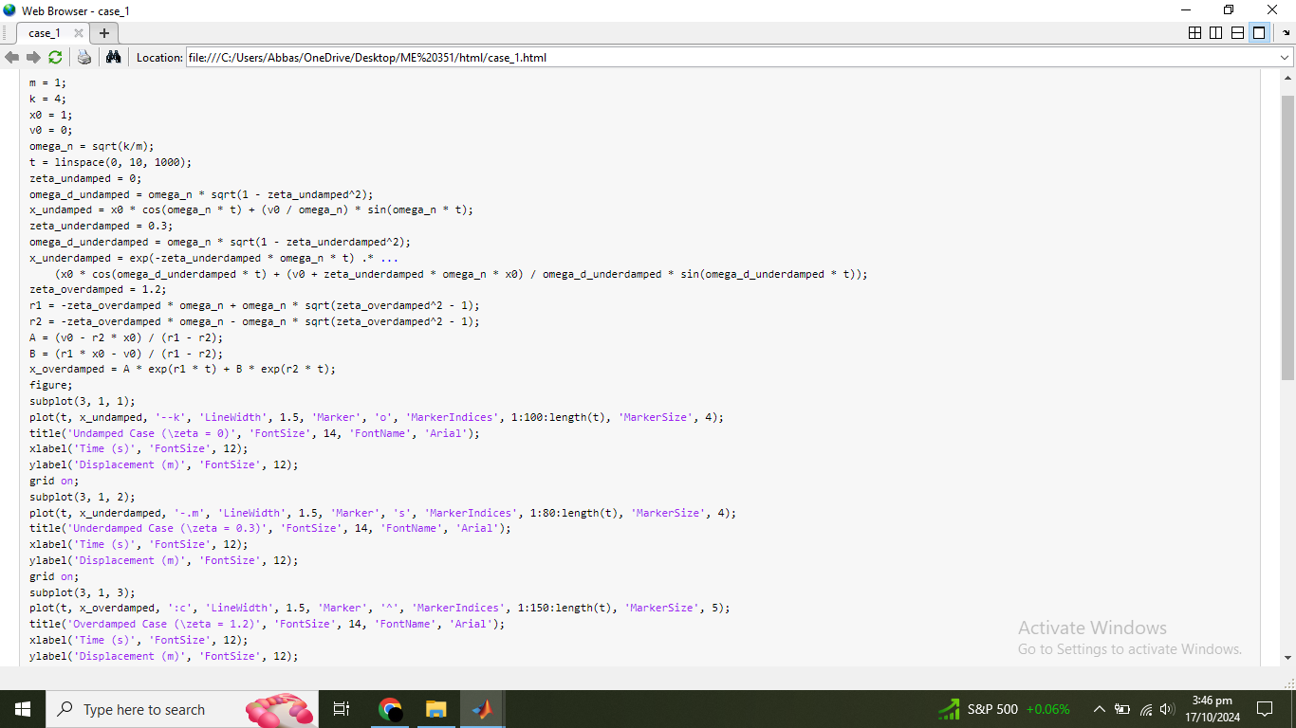

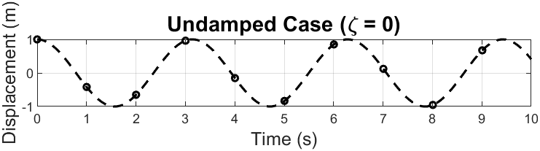

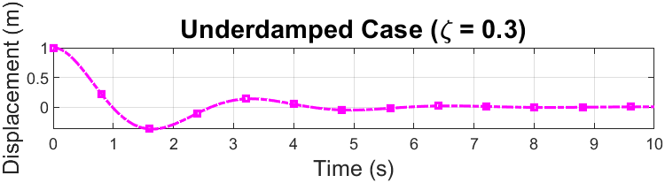

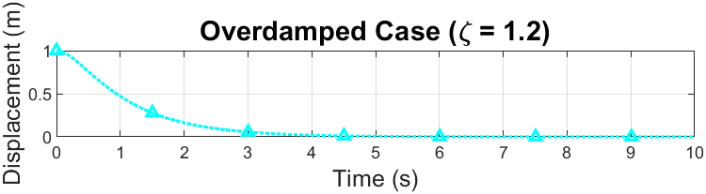

**Case 2:**

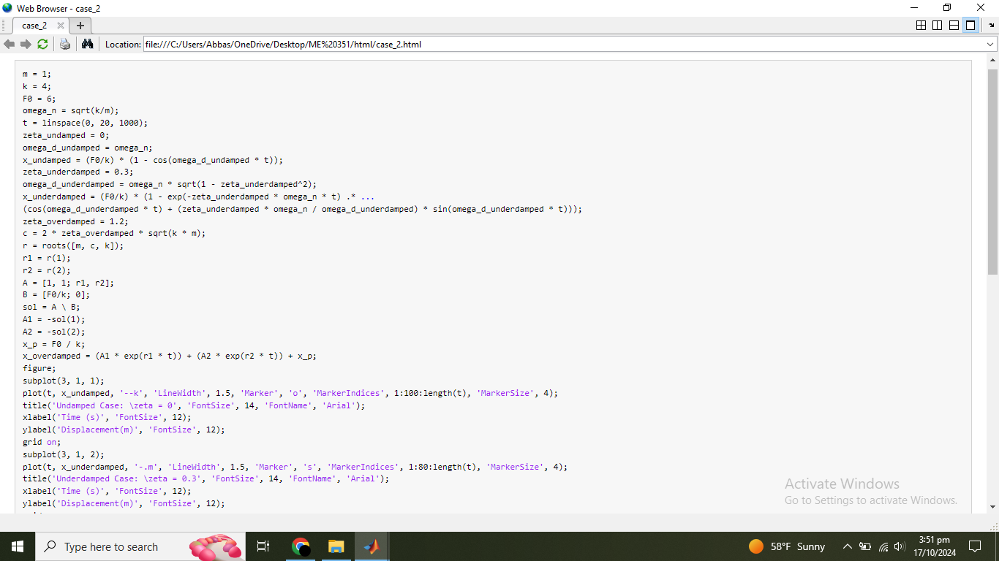

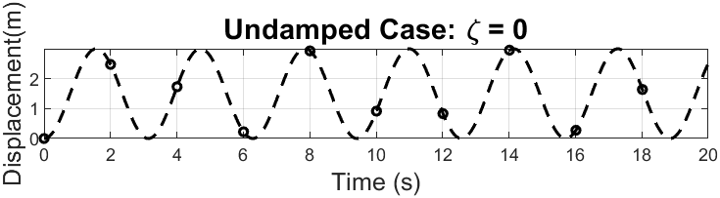

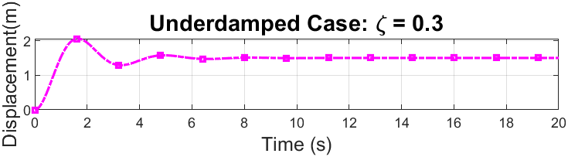

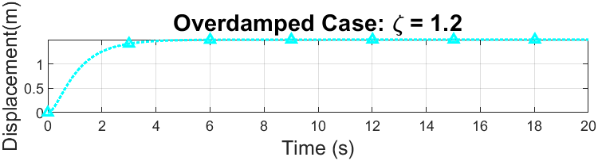

**Case 3:**

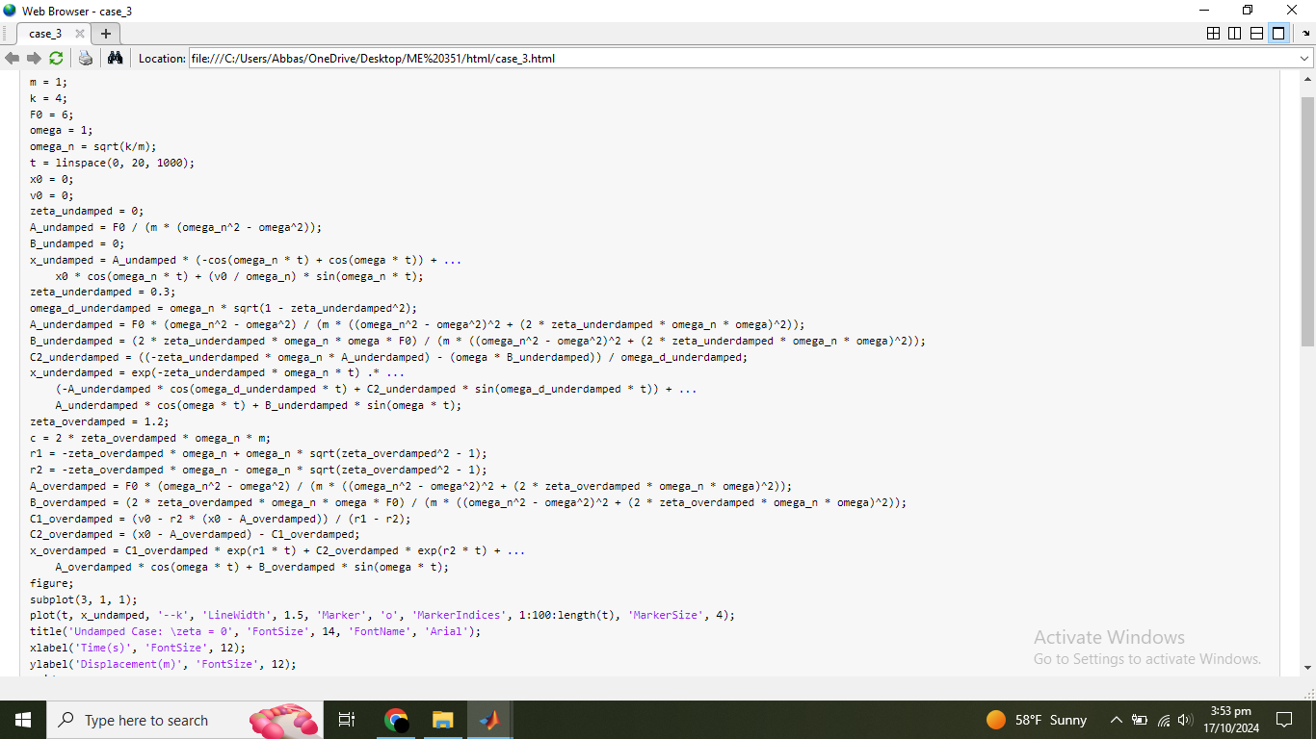

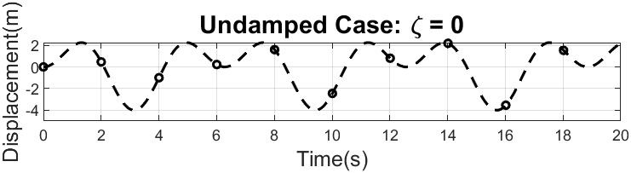

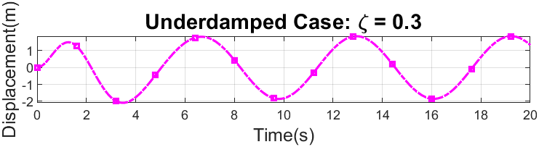

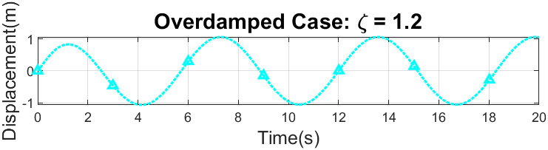

**Summary**

To conclude, in this project we focused on the analysis of second-order dynamic systems under various damping conditions using traditional methods and Laplace transforms. Our objective was to solve homogeneous and non-homogeneous differential equations for different damping ratios (undamped (ζ = 0), underdamped (ζ = 0.3), and overdamped (ζ = 1.2)) and to observe how the system responds under these conditions. We conducted analysis for cases with no external forces, constant forces, and sinusoidal inputs. We also used numerical simulations on MATLAB to verify analytical results and gain deeper insight into both transient and steady-state behaviors of the system.

The calculations were divided into different cases, including undamped, underdamped, and overdamped systems. In each case, traditional methods, Laplace transforms, and linear algebra methods were employed to solve the system differential equations. The simulations for these cases confirmed the analytical findings, with graphical representations helping to visualize system behavior under different damping conditions.

The project concluded that traditional, Laplace, and linear algebra methods yielded consistent results across all cases, and MATLAB simulations successfully visualized these behaviors, offering a comprehensive understanding of the system's dynamics under varying damping conditions.

**Appendix**

**Case 1:**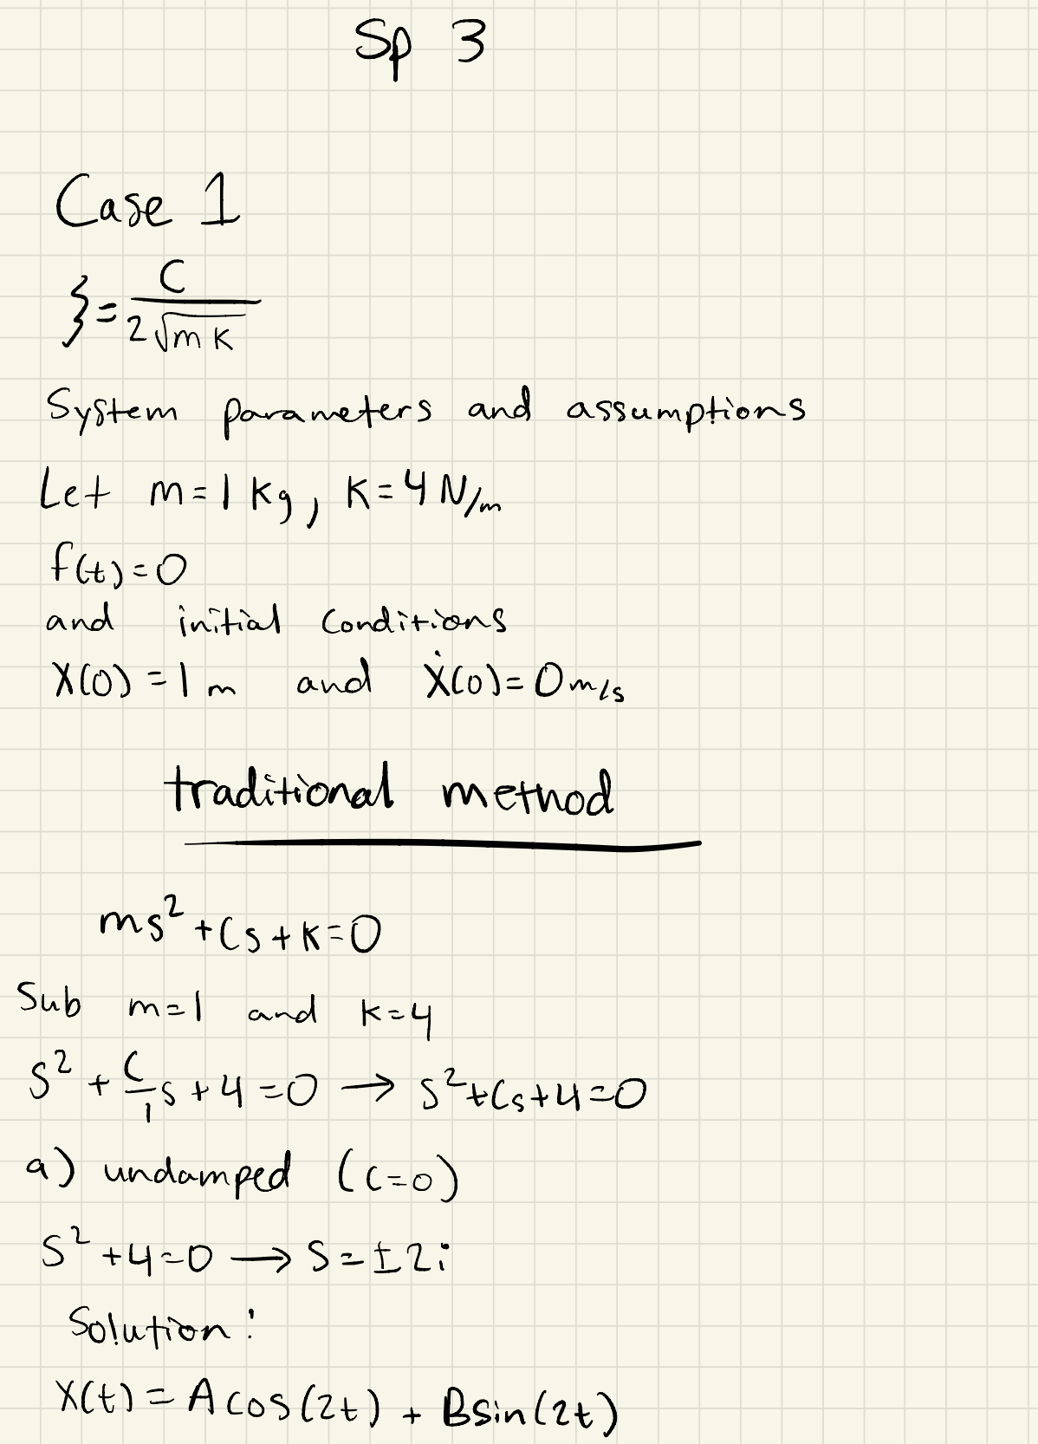

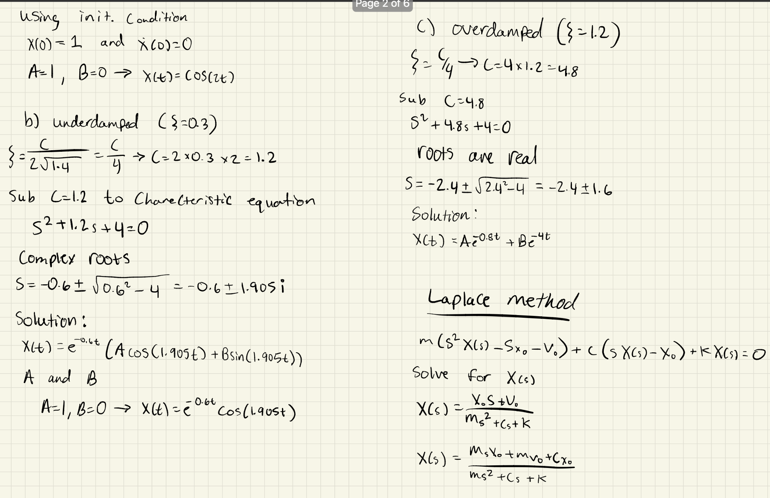

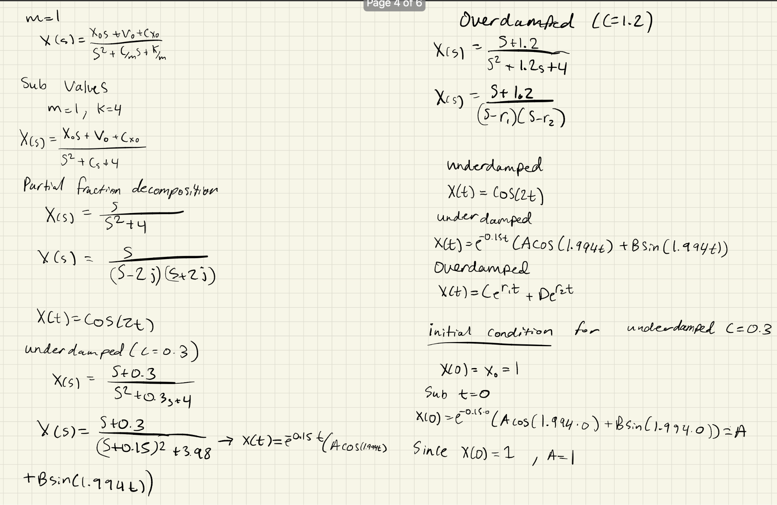

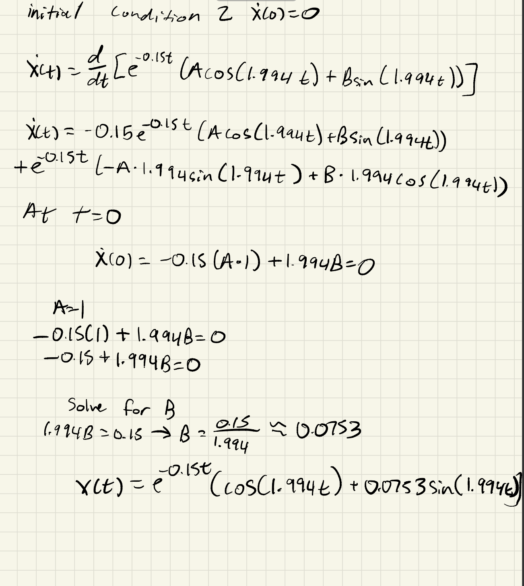

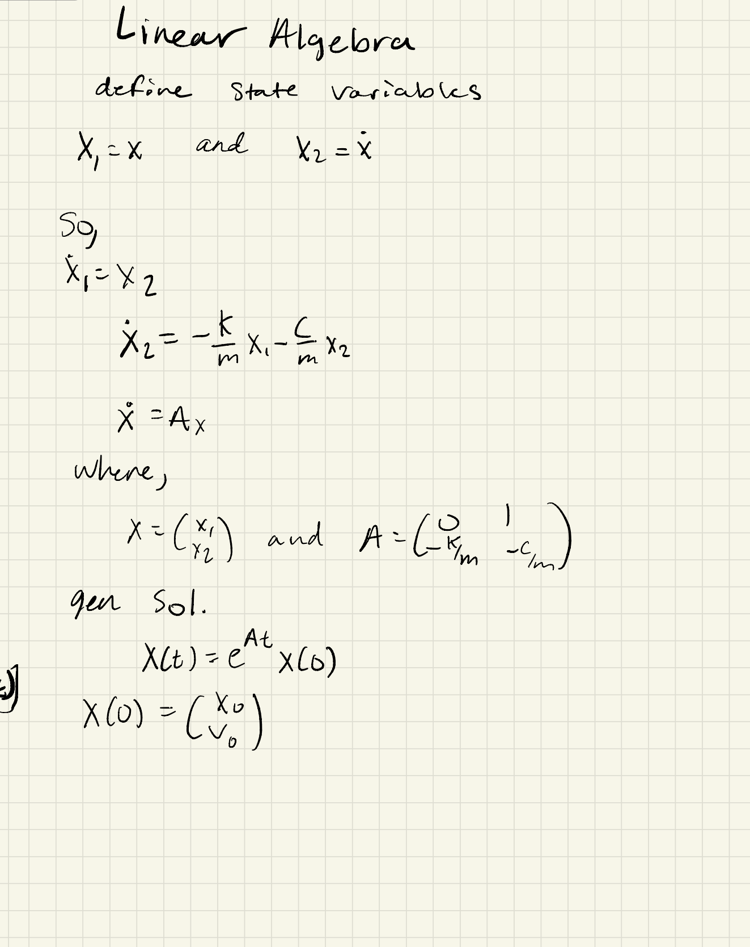

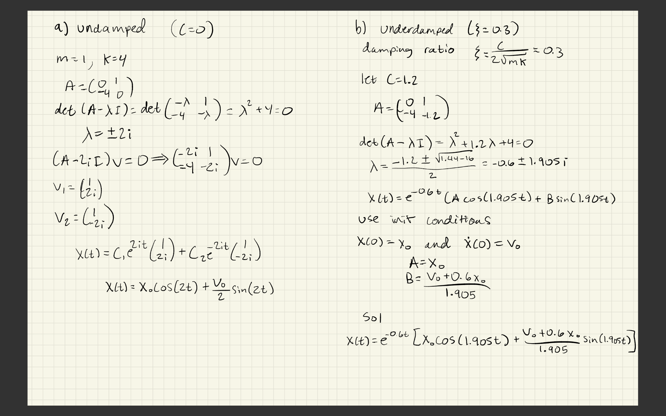

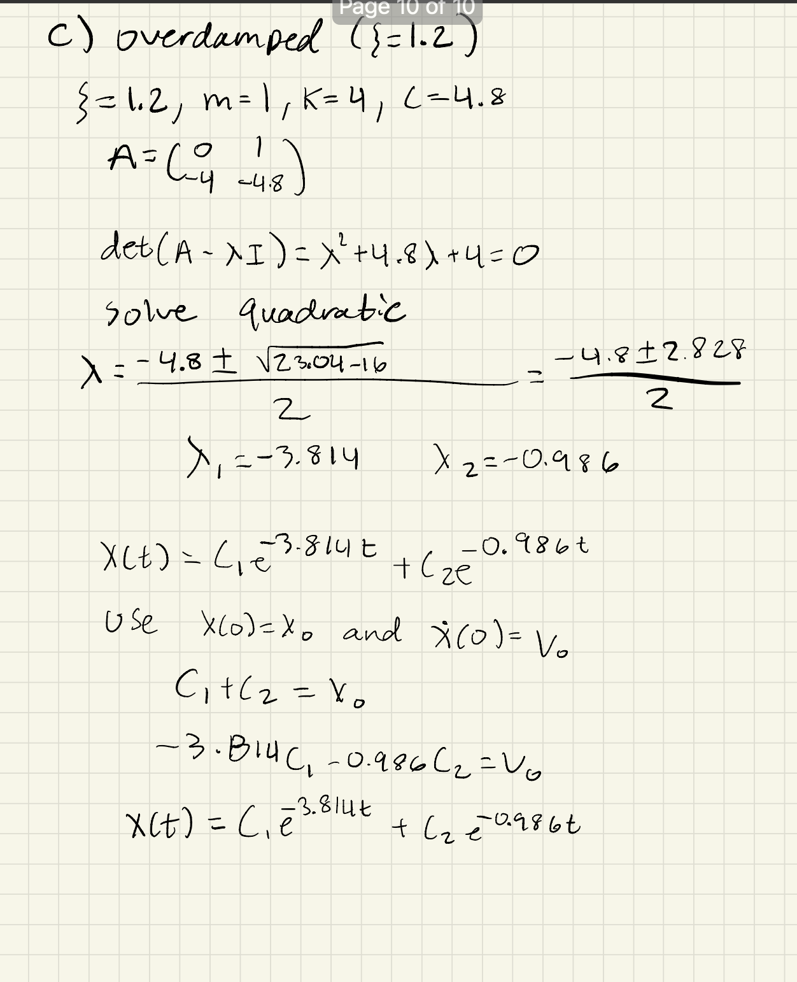

**Case 2:**

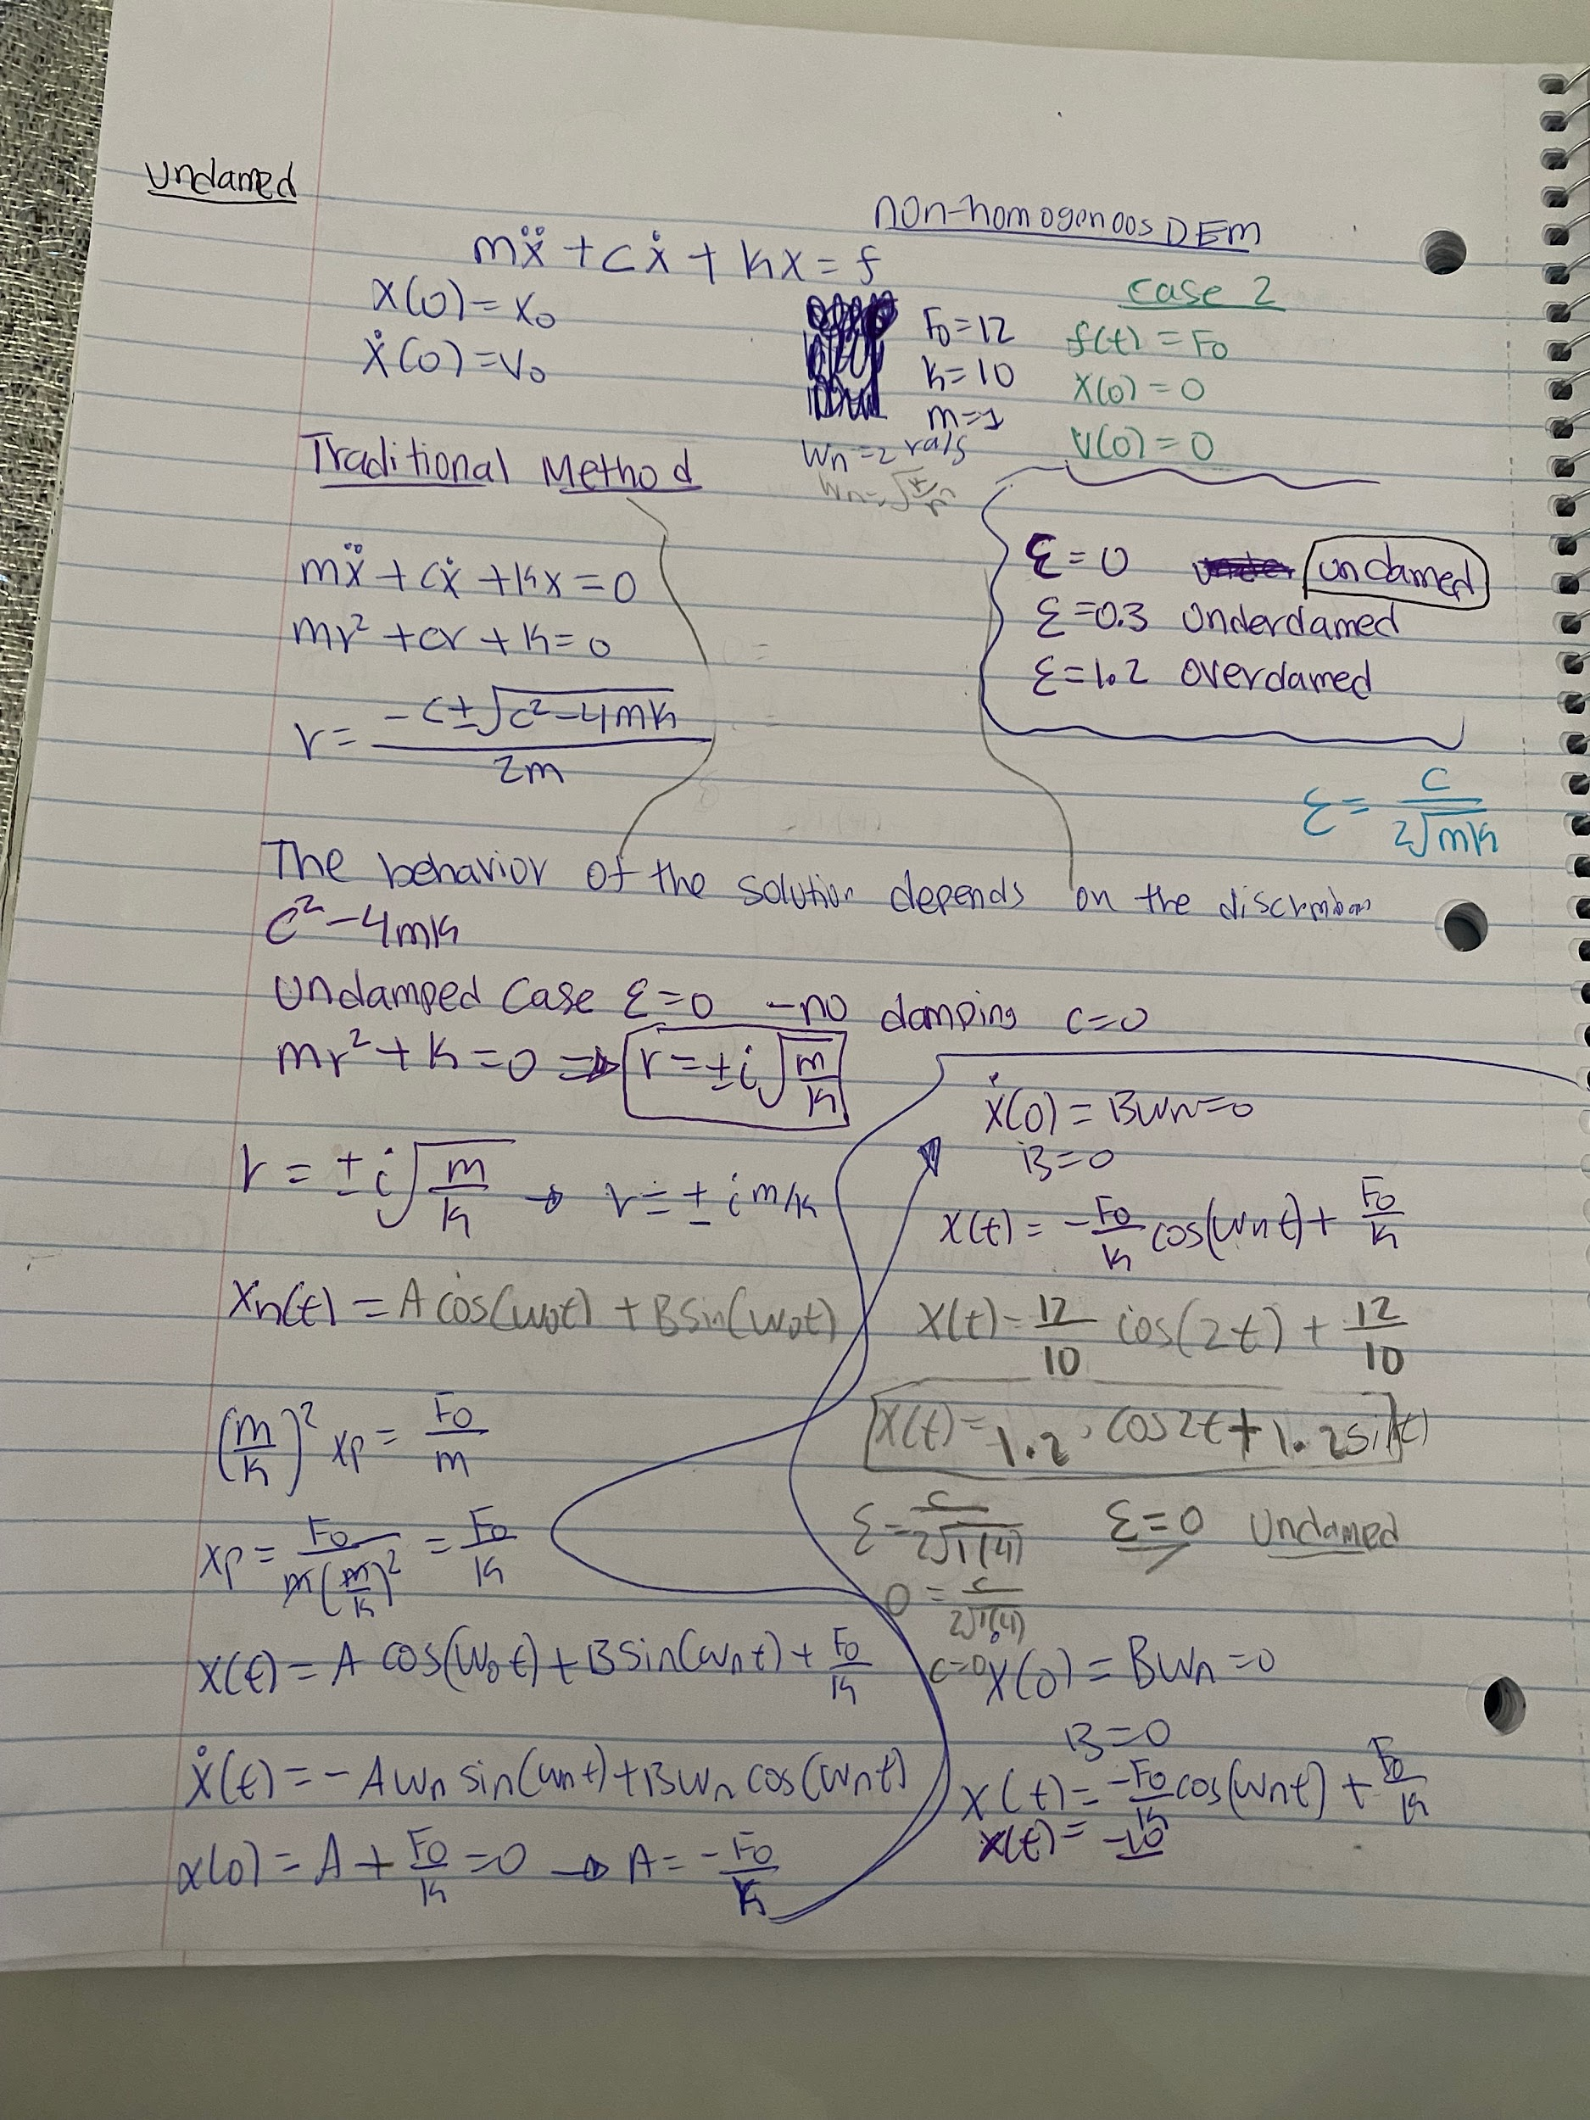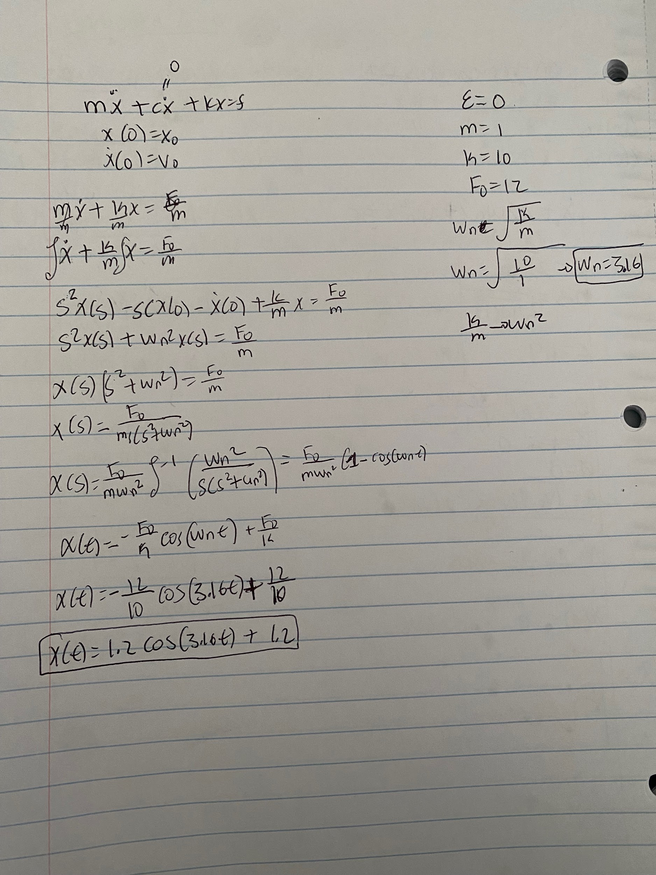

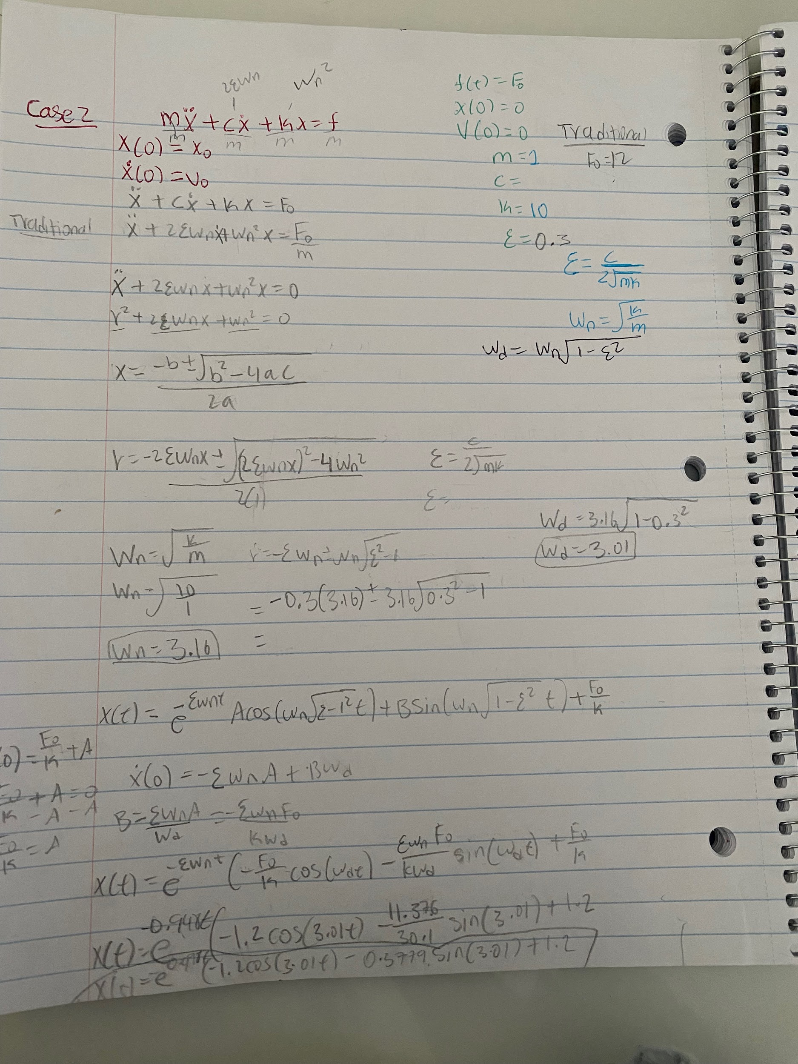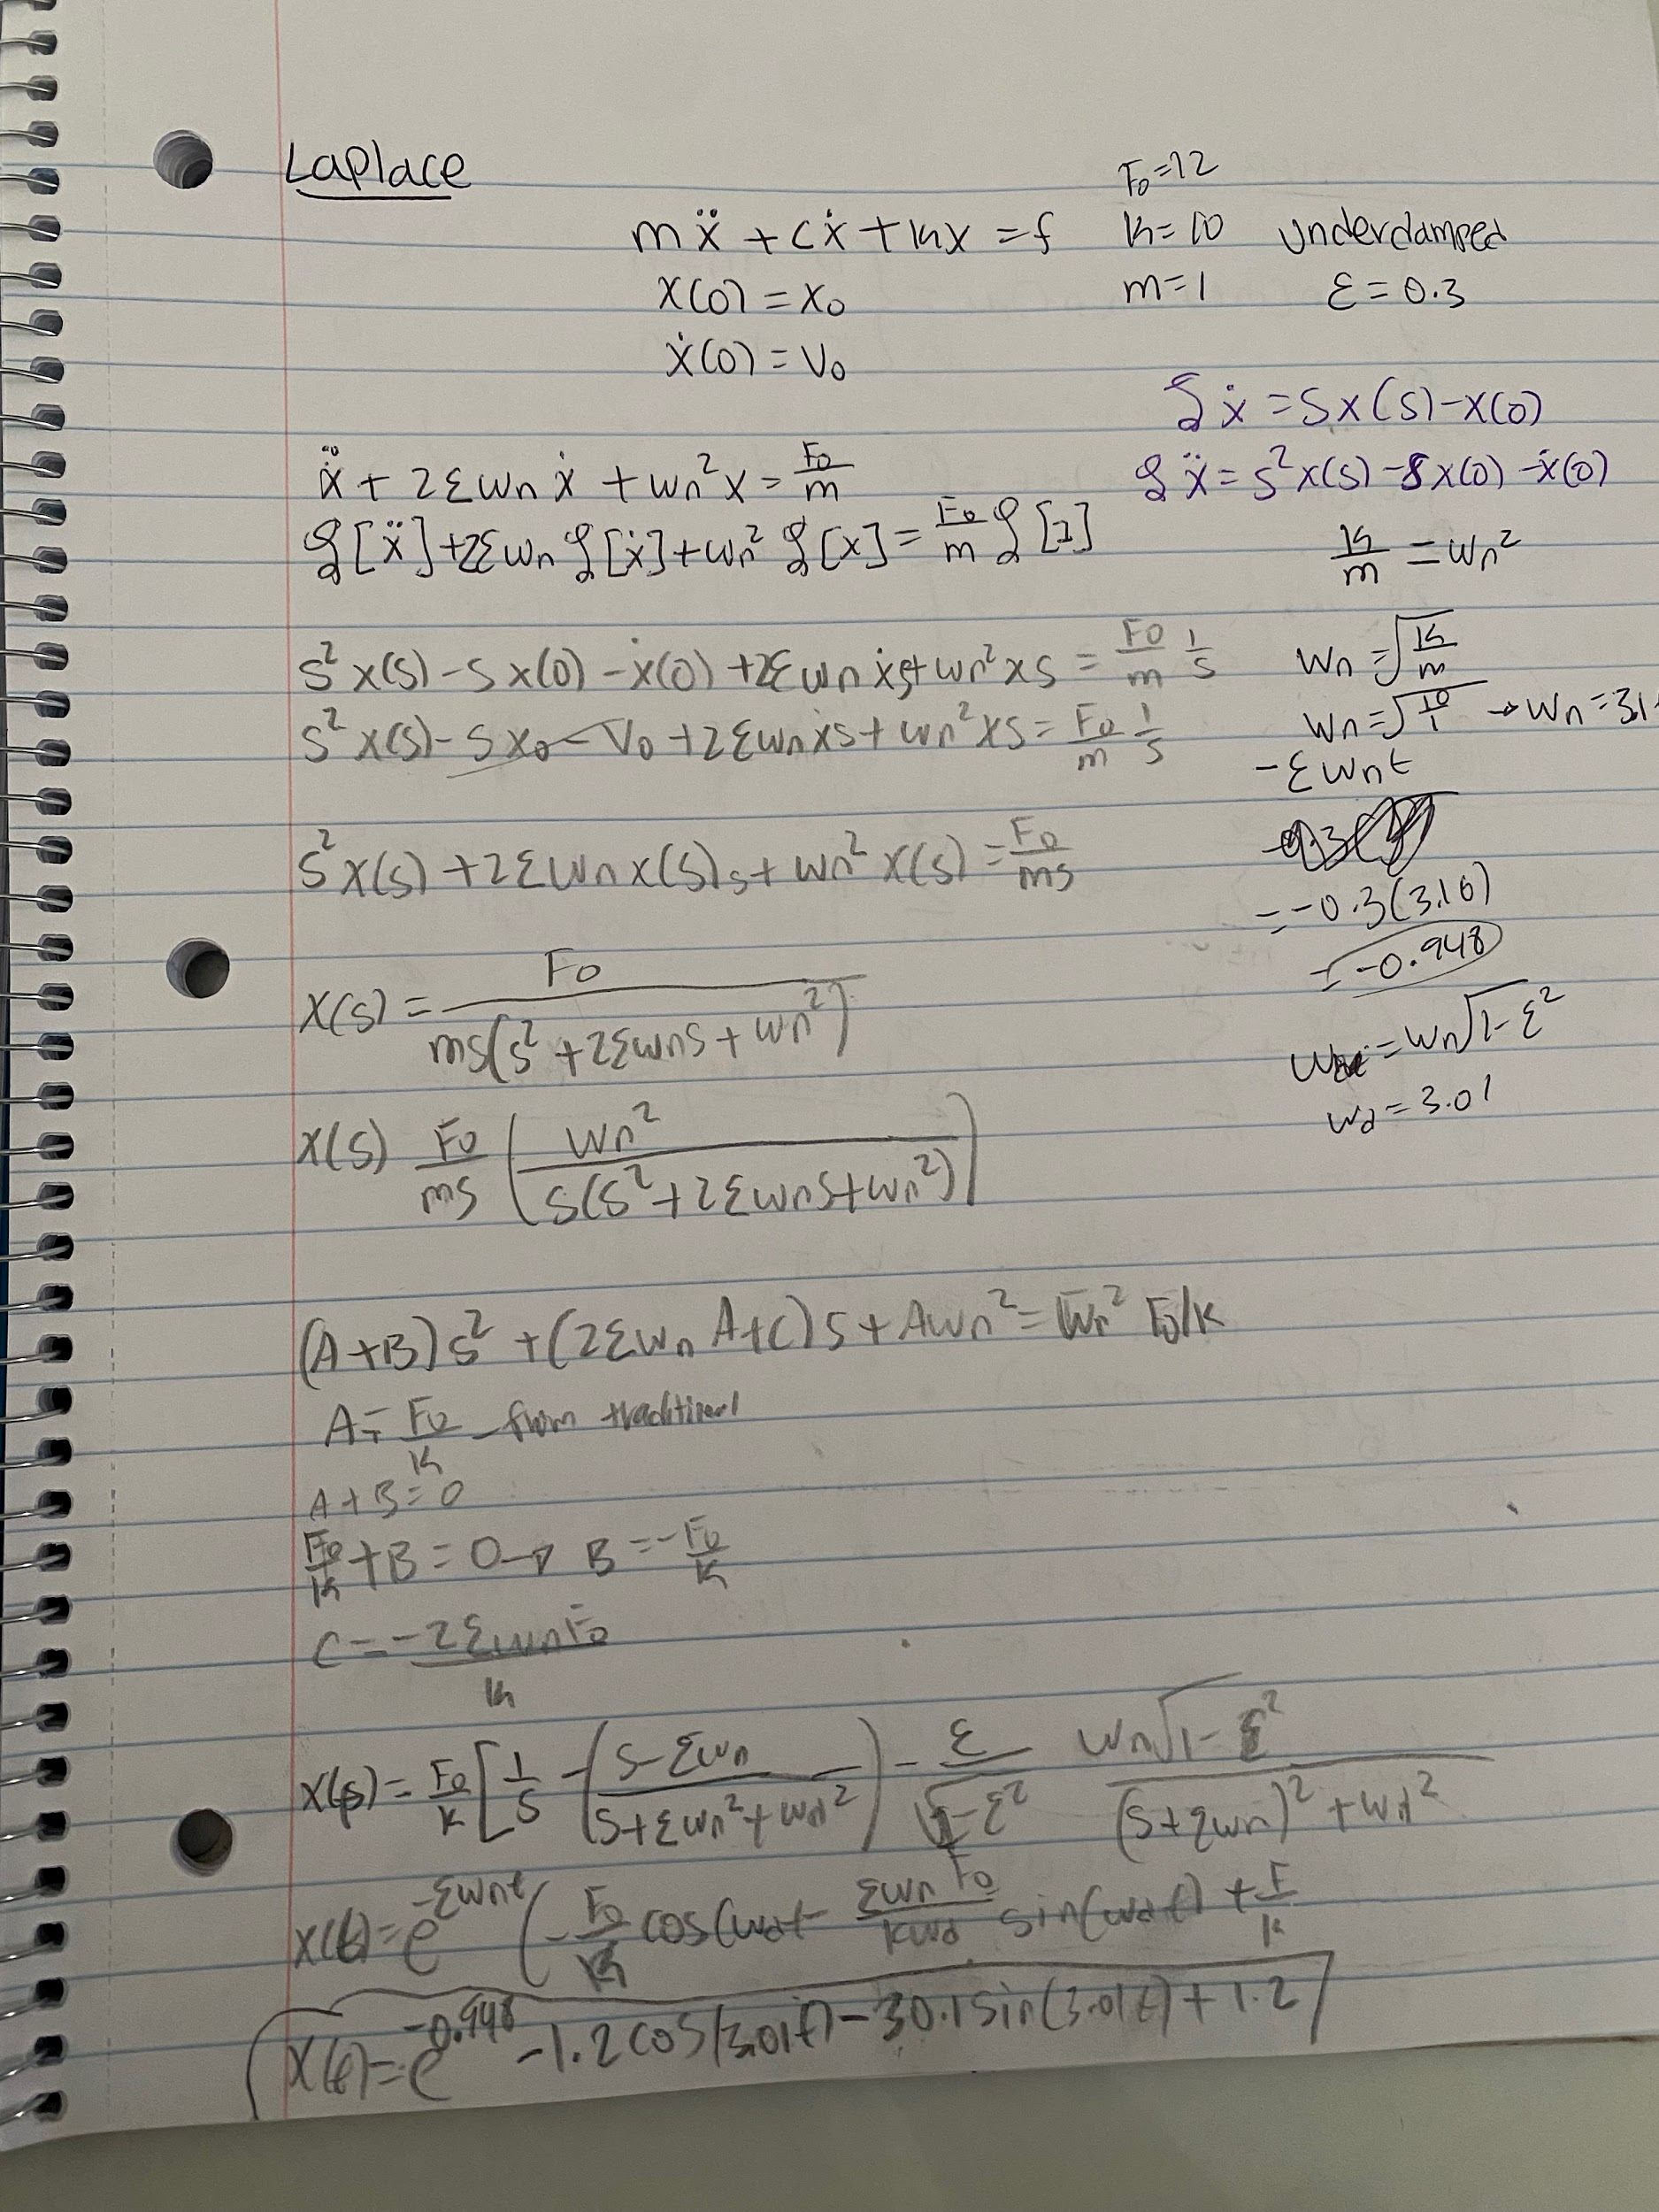

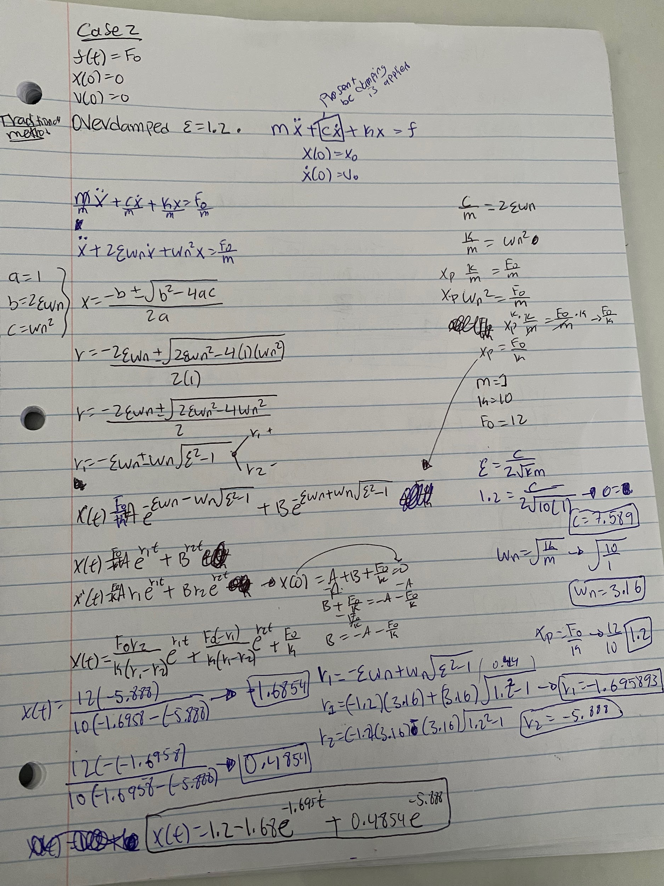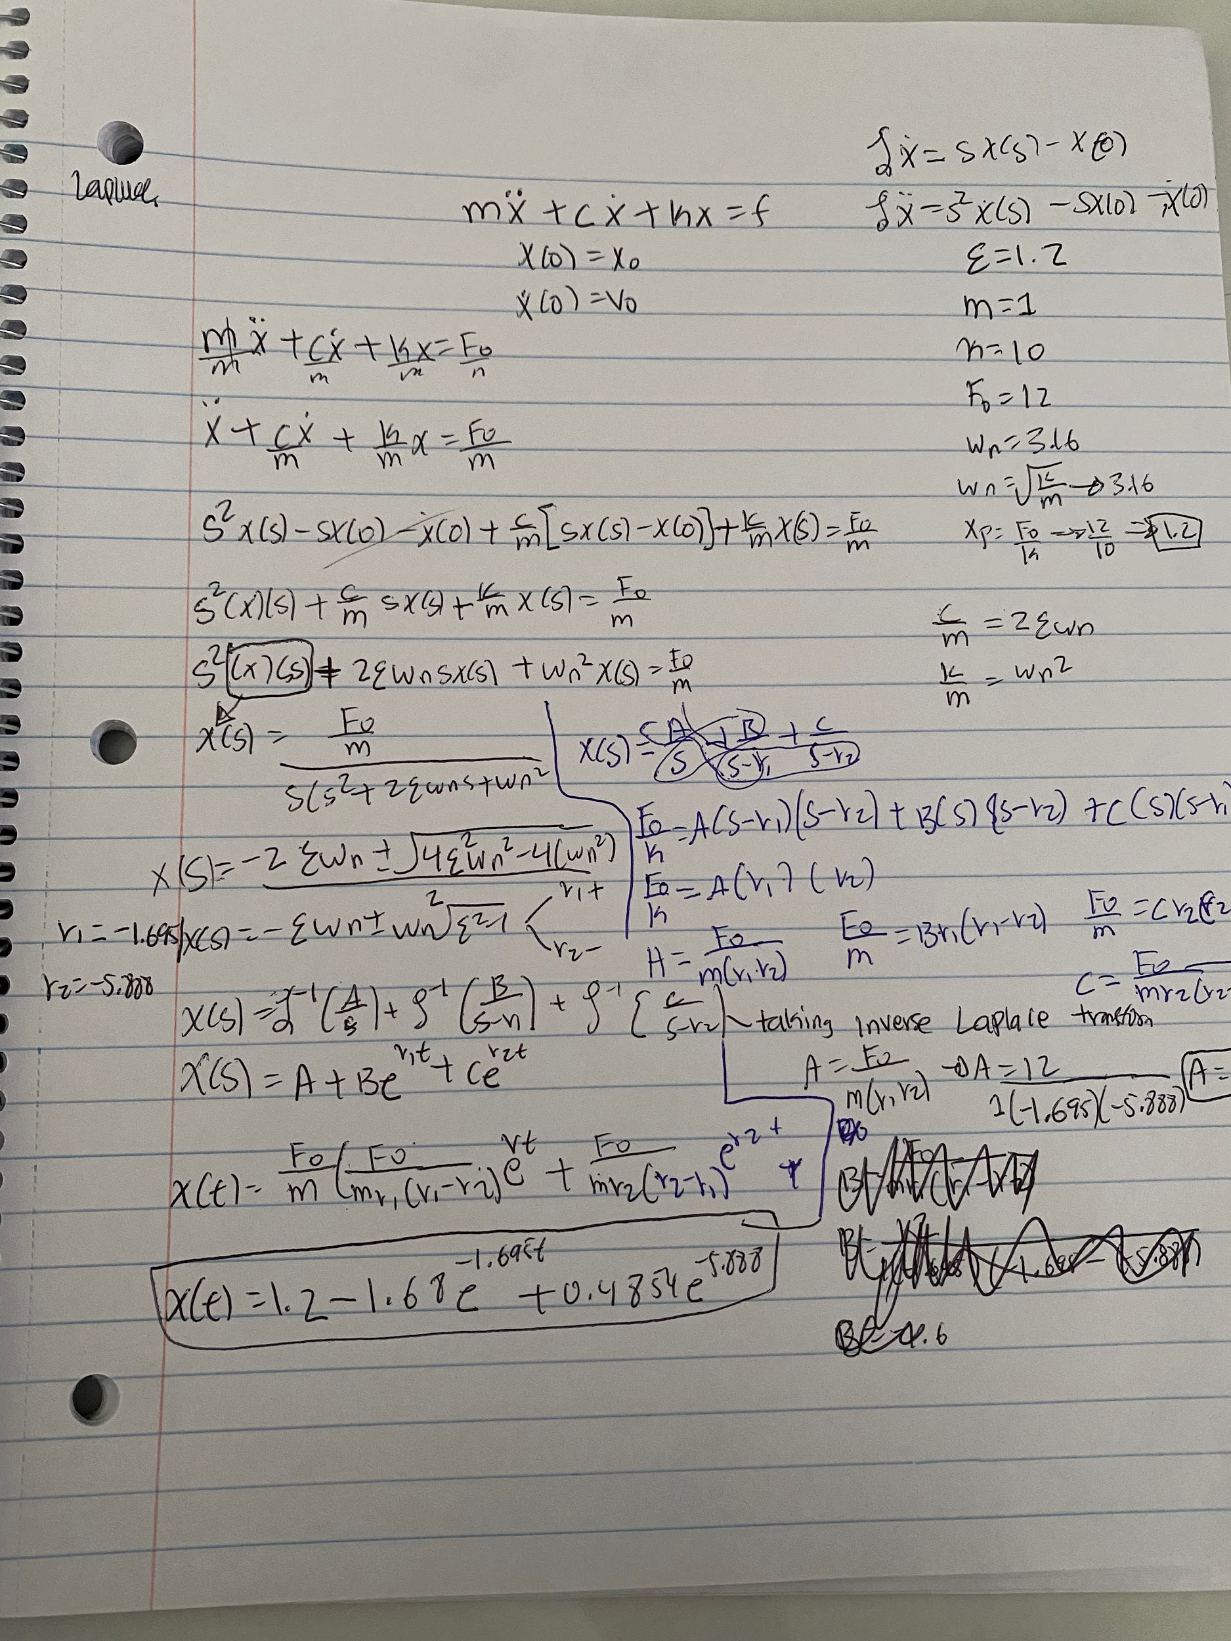

**Case 3:**

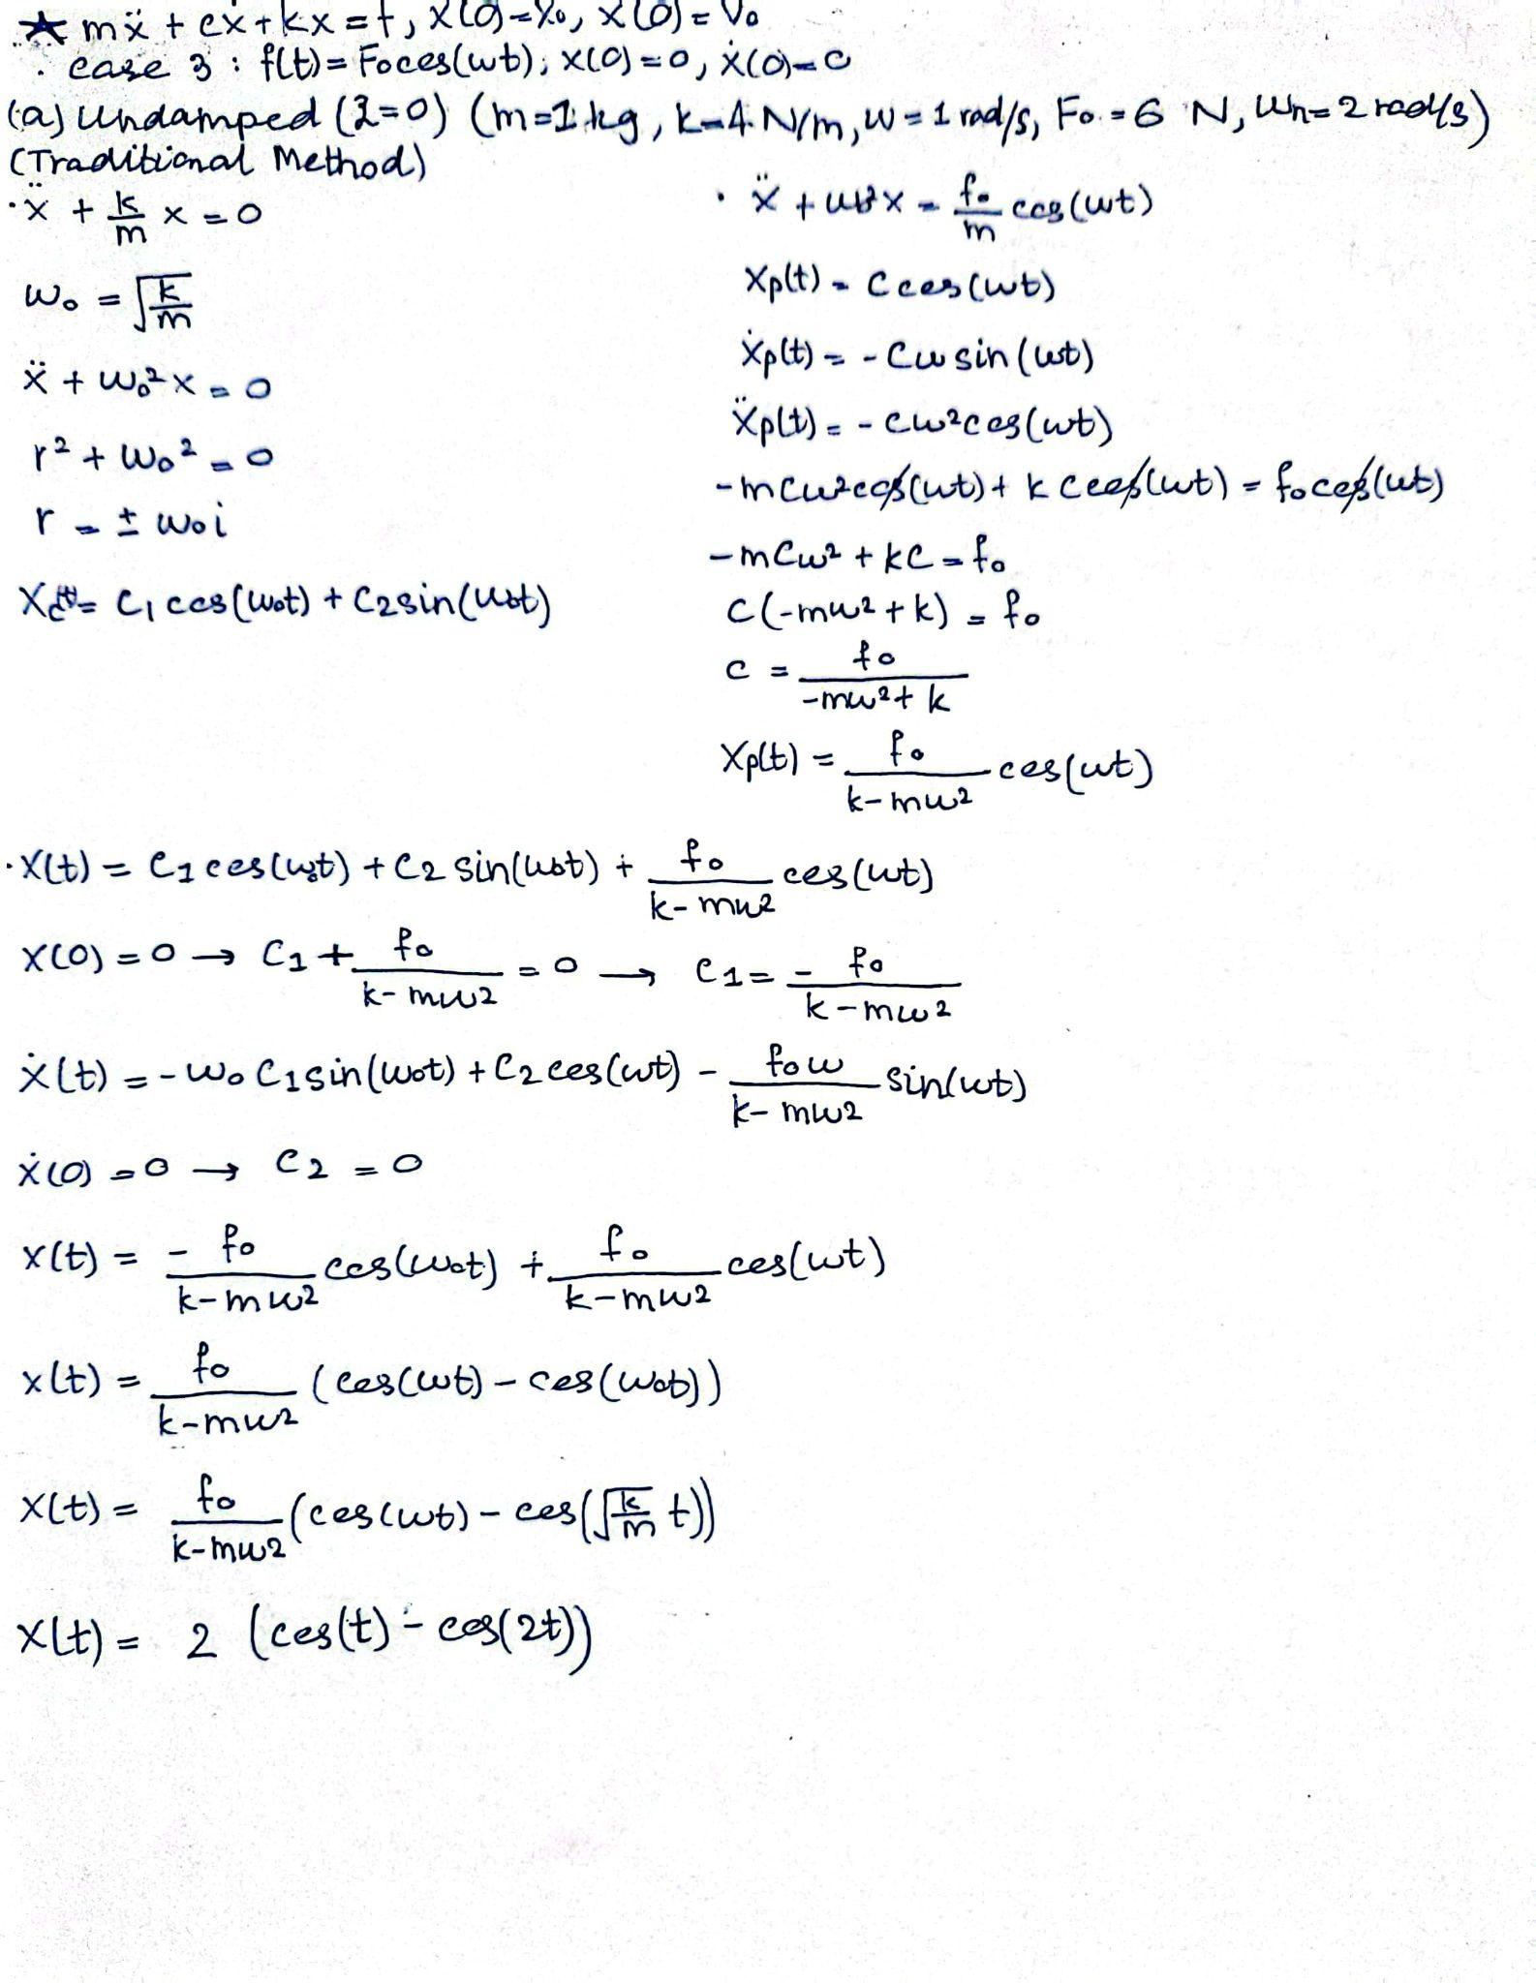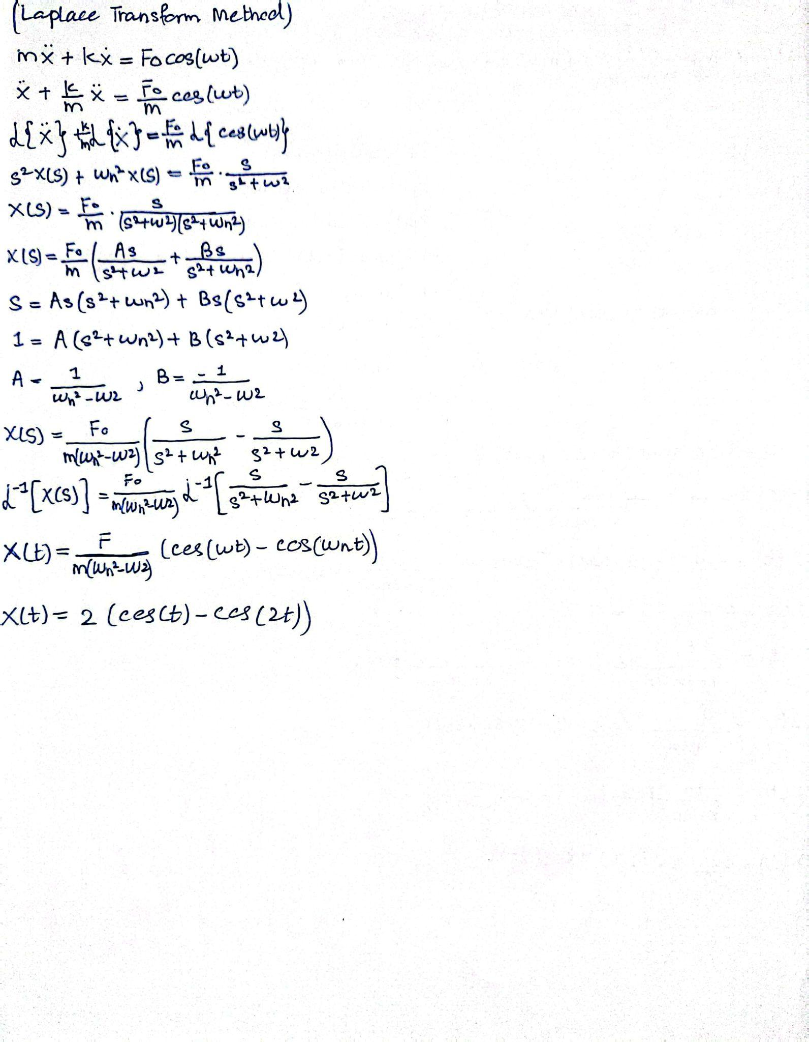

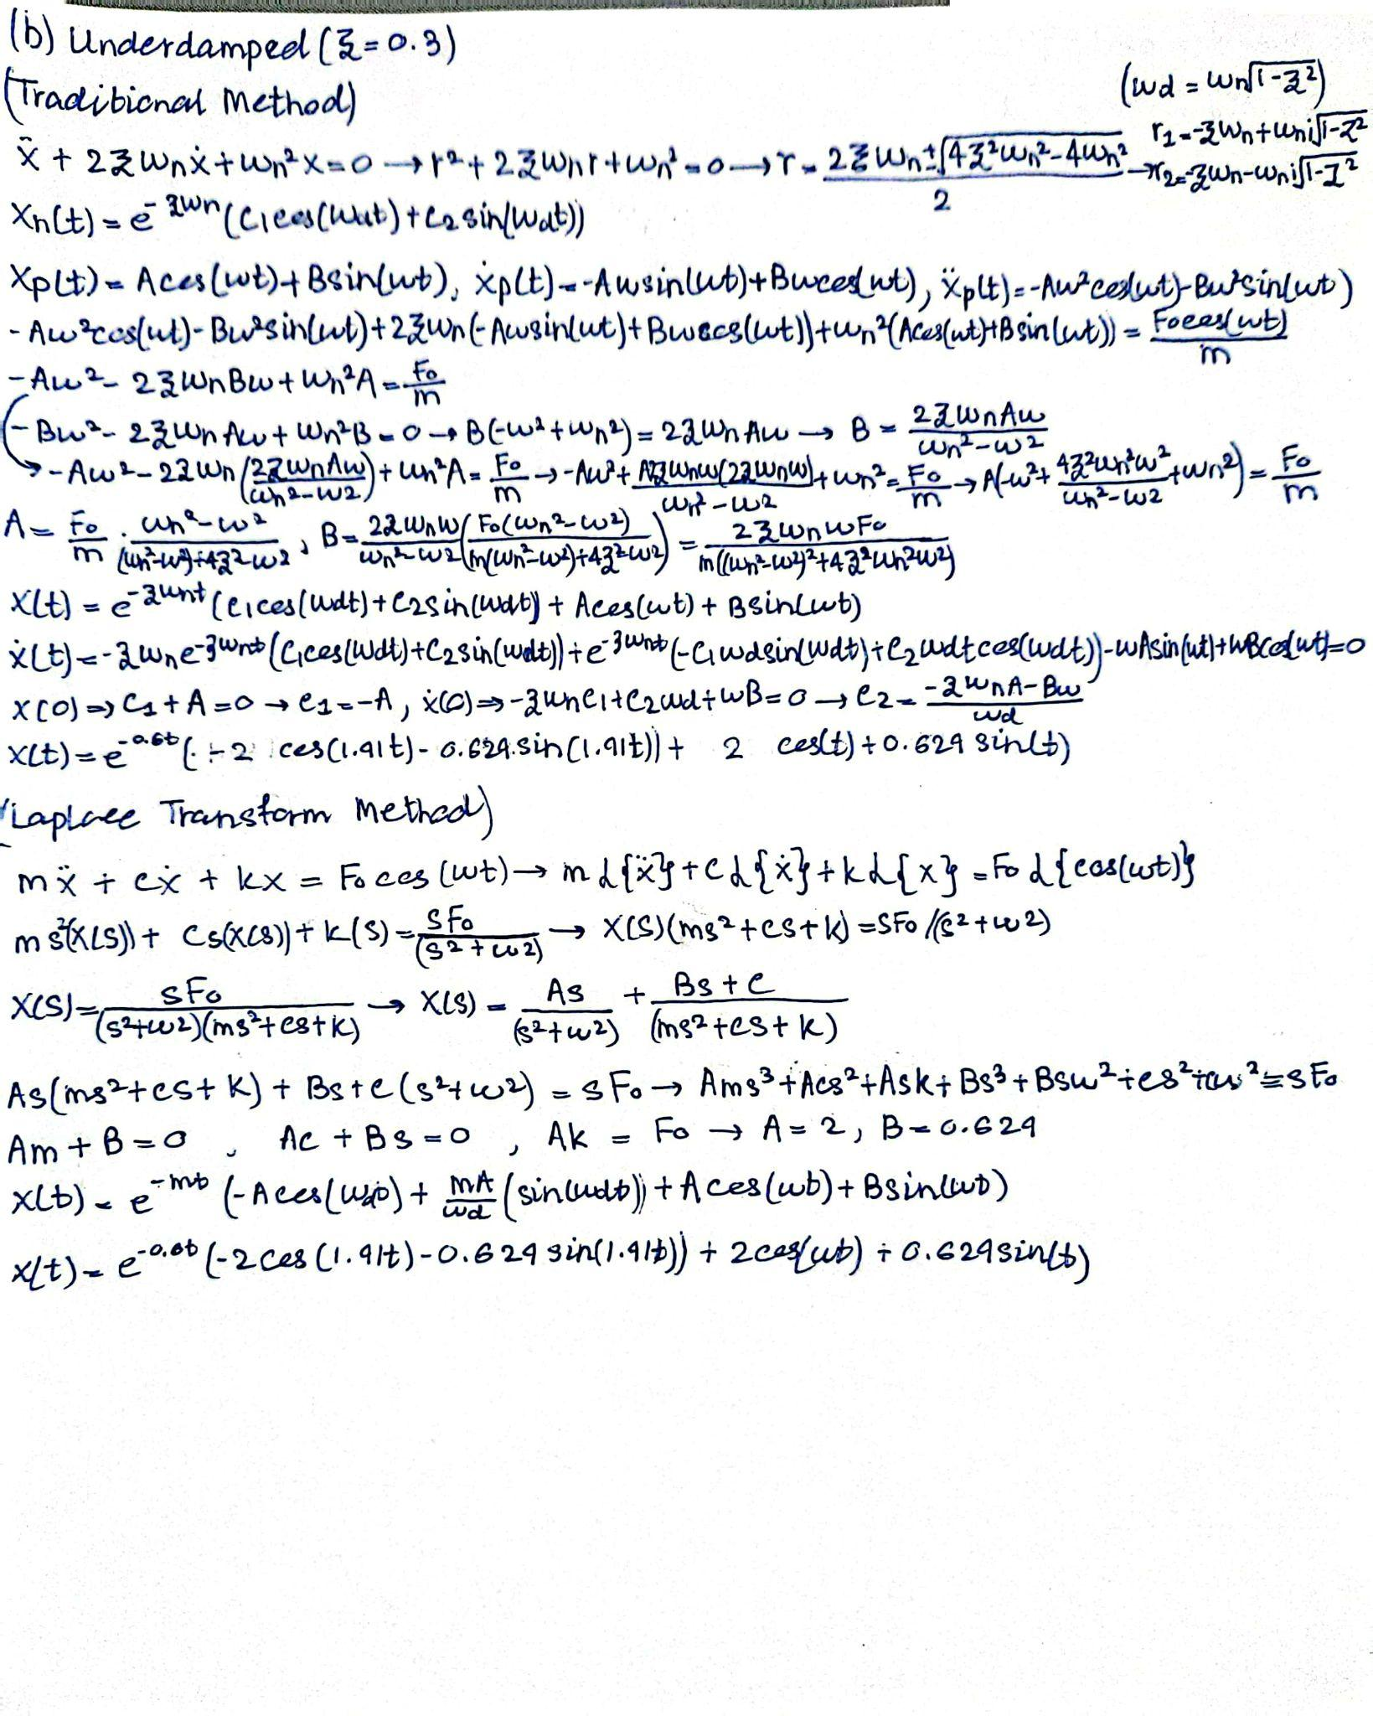

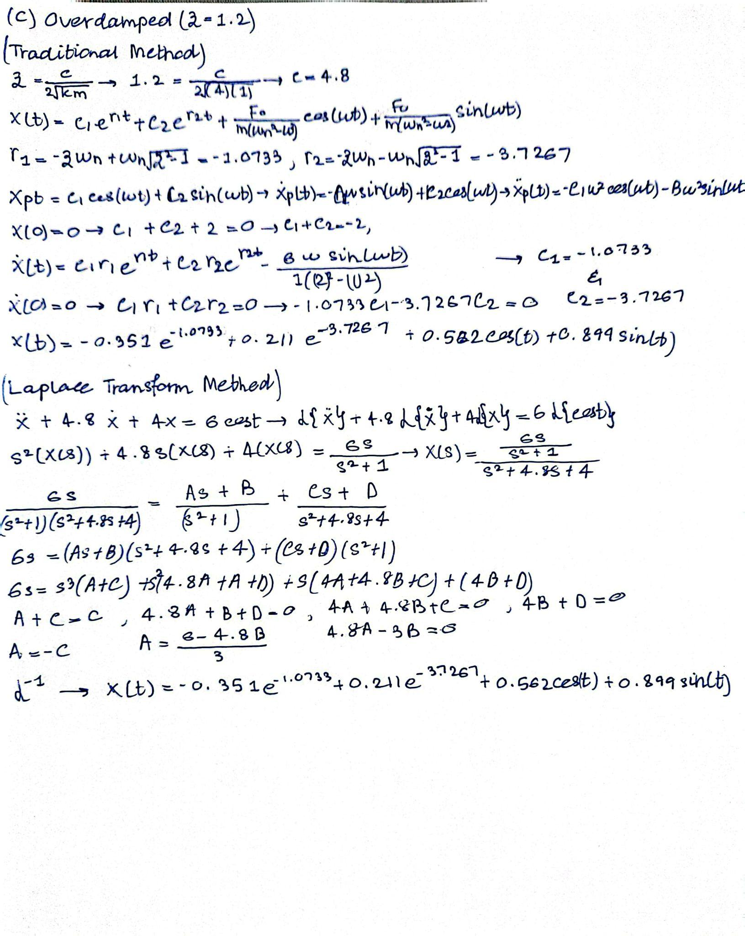

**Assumptions**

**Linear System Behavior:**

* Assumption: The system is assumed to be linear, meaning the relationship between input and output is directly proportional.
* Reason: This simplifies the mathematical modeling and allows for the use of linear differential equations. Real systems might exhibit nonlinearity under large displacements or forces, but for small displacements, this assumption holds valid.

**Constant Damping Ratios:**

* Assumption: The damping ratio (ζ) is constant for all cases and remains unchanged throughout the analysis.
* Reason: Assuming a constant damping ratio allows us to model the energy dissipation in a simplified manner. In reality, damping may vary with temperature, wear, or material properties, but these factors are ignored for the purpose of consistent calculations.

**Neglecting Nonlinearities:**

* Assumption: Nonlinear effects such as material deformation, friction, or temperature changes are neglected.
* Reason: Nonlinearities would make the system behavior unpredictable and more complex to solve. This assumption ensures the focus remains on analyzing the system's primary behavior using linear equations.

**Small Oscillations and Small Strain:**

* Assumption: The system undergoes small oscillations and experiences small strain, which justifies the use of linear elastic theory.
* Reason: Small oscillations allow the use of linear equations of motion. Large oscillations may introduce nonlinear effects like large deformations or complex damping behavior, which are ignored in this analysis to keep the system simple.

**No External Disturbances:**

* Assumption: External disturbances such as friction, noise, or air resistance are negligible.
* Reason: Ignoring external forces helps to focus on the system's internal dynamics, specifically on the damping and restoring forces. In reality, friction and air resistance may introduce additional forces, but they are assumed to be small and inconsequential in this analysis.

**Ideal System Components:**

* Assumption: The system components (mass, spring, damper) behave perfectly, with no degradation or imperfections.
* Reason: Real-world imperfections like wear, fatigue, or temperature effects are neglected to focus on the core system behavior. Ideal components provide a controlled environment for the theoretical analysis.

**Constant External Forces:**

* Assumption: When external forces are applied, they are assumed to be constant or sinusoidal as specified in the problem.
* Reason: Assuming constant or sinusoidal external forces allows for clear analysis of system response. Real-world forces could vary unpredictably, but these variations are neglected to simplify the model.